This Week in Saratoga County History

Memorial Day Observances – May 21

Today The Saratoga County History Roundtable presents three short pieces of Memorial Day observances around the county over the years.

Submitted by Rachel Clothier, Corinth Town Historian

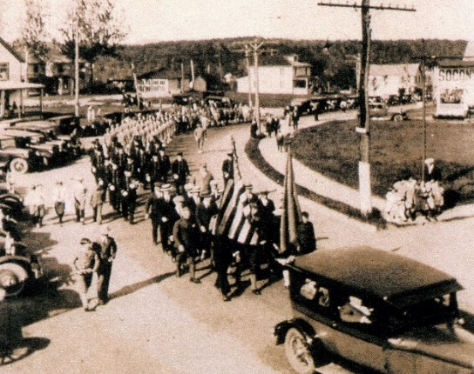

Corinth Memorial Day Parade 1927
Memorial Day has been observed in Corinth for nearly 150 years with the Grand Army of the Republic (Civil War veterans) beginning the tradition. Originally called Decoration Day for the decoration of the graves of soldiers with flowers. In a May 1892 Corinthian newspaper article it was stated "the grave of every known soldier, of every war in this country is a scared mound set apart to be decorated with flowers as a fitting beautiful expression of the gratitude we cherish in memory of the heroic deeds, sacrifices, and sufferings." Parades in the village of Corinth were held each year and in 1906 Shorey's Military Band played inspiring music for the procession. For the past several years an anonymous donor has paid for the parade to be held on the original date of Memorial Day - May 30, not the Monday date that was adopted in 1968 known as the Monday Holiday Act which was enacted in 1971.
George L. Kilmer stated in 1892 " the observance teaches the nation to know itself.
+++++++++++++++++++++++++++++++++++++++++++++++++++++++++++++++++++

Submitted By Rick Reynolds Ballston Town Historian
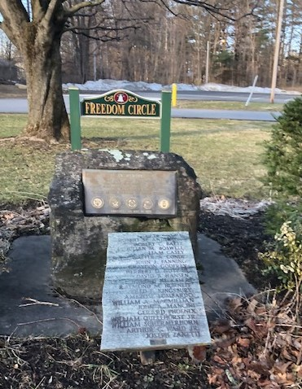
Freedom Circle BHBL High School

Ever seen “Freedom Circle,” the circular drive in front of Burnt Hills-Ballston Lake High School with the monument in the middle? On May 28, 1973 that monument was dedicated to all the men and women who gave their lives in the service of their country. The bronze plaque was supplemented by a Crimson King Maple tree which still stands proudly there today.
On a day set aside by the High School each year, a day near to Memorial Day weekend, the Senior class along with the band and chorus do a short ceremony at that monument and show their respect for all of the veterans who have and continue to serve our country. The rest of the school watches a live feed of the event in their classrooms and veterans from the area are always invited to be a part of the ceremony, too.

+++++++++++++++++++++++++++++++++++++++++++++++++++++++++++++++++++

Submitted by John L. Scherer Clifton Park Town Historian

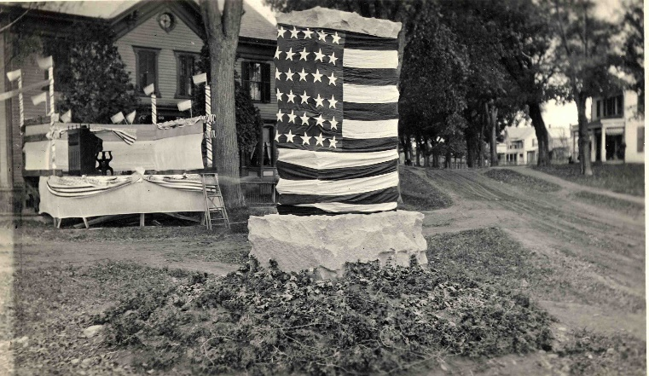

Dedication of the World War I monument, Old Route 146 and Route 9, looking south down Route 9, Memorial Day, 1919. The building on the left is now Snyder’s Restaurant. A parlor organ is set up on a temporary stage to provide music for the occasion.
In 1919, shortly after World War I (1917-1918), the Towns of Clifton Park and Halfmoon jointly erected a monument to commemorate those who served in the World War from both towns. Located in the hamlet of Clifton Park, this tall granite monument with large bronze plaques on both sides was placed in the middle of Route 146 at the intersection of Route 9, in front of the Clifton Park Hotel. It straddled the town line and the Halfmoon soldiers appeared on the east facing plaque and the Clifton Park soldiers appeared on the west facing plaque.
When Route 9 was widened to a four-lane highway, it became very difficult to plow snow around the monument, and in September 1973 the monument was moved to the Mohawk Post American Legion on Grooms Road that then occupied an old school house where Sorrentino’s Market is now located. In 1985, the monument was moved again further west to the new American Legion building on Grooms Road.

