This Week in Saratoga County History

Another “Grand” Hotel

Submitted by Mary Ann Fitzgerald June 18, 2020

Mary Ann Fitzgerald, Saratoga Springs City Historian since 2004, earned her Bachelor’s degree in American Studies from Skidmore College in 2000. She retired from Skidmore College in 1999. Mary Ann co-founded the West Side Oral Narrative Project in 1998. She worked for the Saratoga Springs History Museum in the George S. Bolster Collection 2001-2003. You may contact her at maryann.fitzgerald@saratoga-springs.org

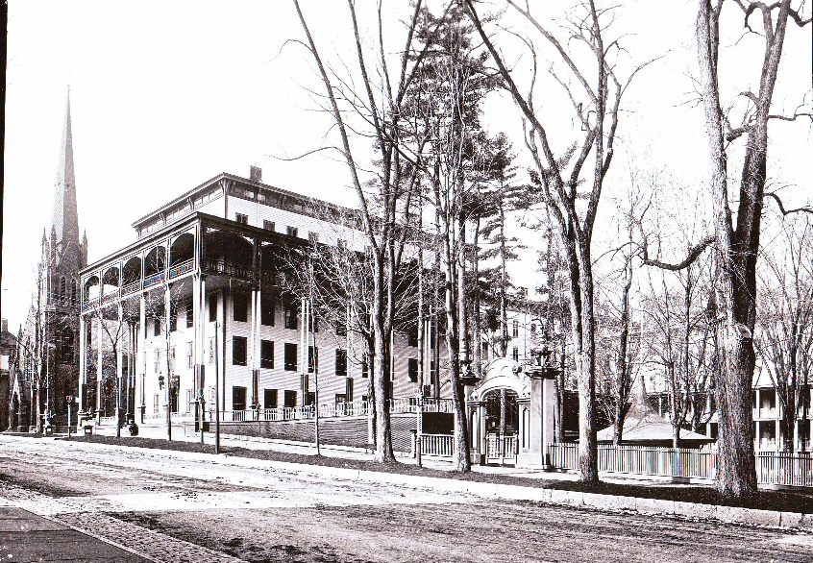

The Clarendon Hotel, Broadway, Saratoga Springs. George S. Bolster Collection.

The United States Hotel once located on the southwest corner of Broadway and Division Street, built in 1824, had grown over the years to have over 500 rooms. On Sunday, June 18, 1865, the guests were readying to take carriage rides out to Saratoga Lake, a favorite diversion of the time, when fire broke out, the flames spreading quickly, devouring the hotel in a spectacular blaze. A year later Congress Hall would burn adding to the shortage of guest rooms available in the resort town of Saratoga Springs. By 1868 Congress Hall was rebuilt, and soon ready to welcome tourists. The United States Hotel left its property vacant for nine long years. The Clarendon Hotel Located on Broadway, adjacent to Saint Peter’s Church, graciously filled the gap in accommodations enjoying its greatest success between 1865 and 1874.
The Clarendon evolved from a boarding house first opened in 1840 by the Brotherson sisters catering to fashionable society. In 1860, Mrs. Mary I. Jones purchased the boarding house, made many changes and named it The Clarendon. Mrs. Jones hired Alexander Putnam to manage the hotel. In the midst of the Civil War, Charles E. Leland, of the Leland’s Associated with the Grand Union Hotel, leased the Clarendon and purchased it ten years later in 1873. Leland also purchased the Washington Spring and incorporated it into the Clarendon Hotel property.
The Clarendon Hotel, a wooden structure, was painted white with green shutters on every window. The Washington Spring, on the grounds of the Clarendon had been discovered and tubed by Gideon Putnam in 1806. It was frequently called the "Champagne Spring," for its sparkling properties. It was one of the most popular springs in Saratoga, and was thronged with afternoon visitors. A spring discovered later by Leland was named after him. Three concerts a day were held on the Clarendon’s broad piazza, which extended around the hotel and overlooked a beautifully landscaped interior court. Southwest of the Washington spring were bowling alleys, and a pistol shooting gallery, conducted in the 1880’s by John Gaffney. The Clarendon Hotel and Washington Spring were last listed in the city directory in 1905. The Clarendon was later razed, and the property was purchased by Father James Flood, of Saint Peter’s Church, for future use.
The property remained vacant for 50 years. The excavation of the old hotel left a huge hill running from Broadway to Hamilton Street, that was great for sledding, usually on cardboard boxes. In the 1950’s St. Peter’s Academy outgrew the school building on Hamilton Street. The new St. Peter’s Academy High School, was built on the site of the old Clarendon Hotel and dedicated in November of 1954. The school was renamed Saratoga Catholic Central High School around 1977.

