This Week in Saratoga County History
Christmas edition – December 23, 2021
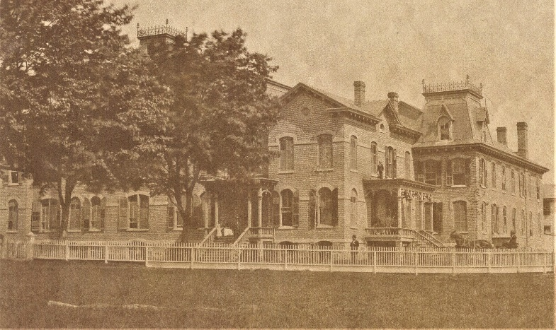
Saratoga County Poorhouse erected 1873
We Need a Little Christmas Submitted by Lauren Roberts, Saratoga County Historian
The end of 1873 ushered in change at the Saratoga County Poorhouse in the form of a brand-new building, along with a novelty the residents had never before enjoyed – a Christmas tree! The county’s original poor house was a modified farmhouse that had been purchased from Hugh Hawkins in 1826 and sat where the current county jail and animal shelter are today in the Town of Milton. With the influx of people to our county throughout the 19th-century, the poor house was no longer adequate to care for the number of people who needed assistance. In 1873, a new two-story brick building was constructed with separate wings for men and women. By the end of the year, it was move-in ready.
In December of 1873, Harriet Story, wife of the Keeper of the Poor House George Story, embarked on a mission to make the holidays a bit brighter for the residents in their care. She solicited donations from visitors and local merchants and even took on the task of holiday decorating. According to an article published in The Saratogian, “On Christmas, a tree was placed in the new office and all of the paupers were asked to assemble in the hall of the new building. The office door was then thrown open and revealed to their astonished gaze the good things that had been provided for them.”
Each woman was given an apron and a handkerchief, girls received a hood and mittens and for the boys, a cap and pocketknife. In addition to the gifts, Miss Rhoda Thompson, of the neighboring Rose Hill Farm, donated apples and popcorn balls, “so that each of the inmates had something to remind them of Christmas, and that others felt for their uncomfortable condition.” These small acts of kindness brought many residents to tears, a reminder that during this busy time of year, giving to those in need should not be forgotten.
++++++++++++++++
Supporting the Troops at Christmas Submitted by Rachael Clothier, Corinth Village Historian
The Christmas Season is one of sharing and giving. During World War II the generosity of the Corinth community was much like that of small towns around the country. Children as well as adults were active participants in supporting activities on the home front.
Soon after the attack on Pearl Harbor in December 1941, students and teachers in the Corinth schools began purchasing war bonds. Within a year they raised $975. By the Christmas of 1943 $1,726 was invested by the Corinth students according to Supervising Principal Ralph F. Pyle.
The community also supported the war effort by collecting scrap, including metals and newspapers. The Corinth High School faculty in late 1942 conducted a scrap drive. Those who donated material were asked to place it at the curbside and display their S card in the front window. In 1943 Corinth collected 801,850 pounds of scrap.
Troop 1, Corinth Girl Scouts collected salvage grease. The girls were going door to door and asking each household to have the grease ready in a tin can. This grease drive took place in December 1943 during an influenza outbreak that closed the schools. While grease may not sound like a desirable commodity, the US Government actively collected it to produce glycerin-based explosives.
Packages being sent to anyone in the armed forces had to be sent out by late October in order to be delivered by Christmas. Articles had to be wrapped securely and contain no intoxicants, matches, or lighter fluid. Parcels sent to the army or navy men were not to exceed six pounds while other branches of service allowed up to 11 pounds.
In Greenfield Center the Slovak Gymnastic Union Sokols No. 265, a local athletic organization, sent Christmas boxes to more than 40 Slovak men overseas who came from Corinth, Greenfield, and the Saratoga Springs area. Mrs. Joseph Bruchac headed up the committee of women.
The Saratoga Branch of Bundles for America, a part of the authorized government agency known as American Parcels for Prisoners of War Association of Buffalo sent packages to all the prisoners of war from Saratoga County who were being held in Germany. The parcels were packed with food and clothing items requested by the prisoner or his family.
The entire county pulled together to help win the war and support the local troops during the holiday season and throughout the year.

++++++++++++++++
Christmas in a New Church submitted by Rick Reynolds, Ballston Town Historian
Christmas is always a time for great celebration, but 1849 was a year of very special celebration for the new members of the congregation of Calvary Episcopal Church in Burnt Hills, NY. December 25, 1849 was the first time they were all able to meet together in their own church building which had just been constructed at a cost of $2500! The building was located right in the heart of Burnt Hills and situated on Lakehill Road, a street that in later years was renowned for its overarching trees that formed a canopy above the street.
The land for that new church had been donated by Mrs. Cady Hollister and Mr. Isaac Wooley, two local residents. But Rev. Edward Davis, who had previously been a pastor at St. Paul’s Church in Charlton, was probably the most influential in getting the building constructed. He also purchased the building to the west side of the driveway to present-day Burnt Hills-Ballston Lake High School, the building which became the new church’s rectory shortly before his death. In addition, he purchased the lot to the front of the church, which would become land for the Parish Hall in later years.
Dr. Davis, who lived in what we now call the Buell Mansion on Midline Road in Ballston Lake, took no salary as the pastor of the church for over six years. He and his family donated the original baptismal font, the church bell, and much of the land for the cemetery behind the church. Mrs. Davis was also instrumental in funding several stained-glass windows in the church.
In 2017, Calvary Episcopal Church was named to the National Register of Historic Places and, this year, 2021, the church celebrates another major accomplishment: the restoration of the church steeple designed to look very much like the first steeple on the church many years ago.

